Creating Rest API for Product entity to
Store post method
Retrieve - get method
- Get all product details
- Get particular product base upon pid or any other property
  - Query param
URL?key=value
URL?key=value&key=value
  - Path param
URL/value1/value2
Update put or patch method
Delete delete method

https://start.spring.io/

Starter -Web Starter
Jpa - ORM features
My SQL Connector mysql database connectivity

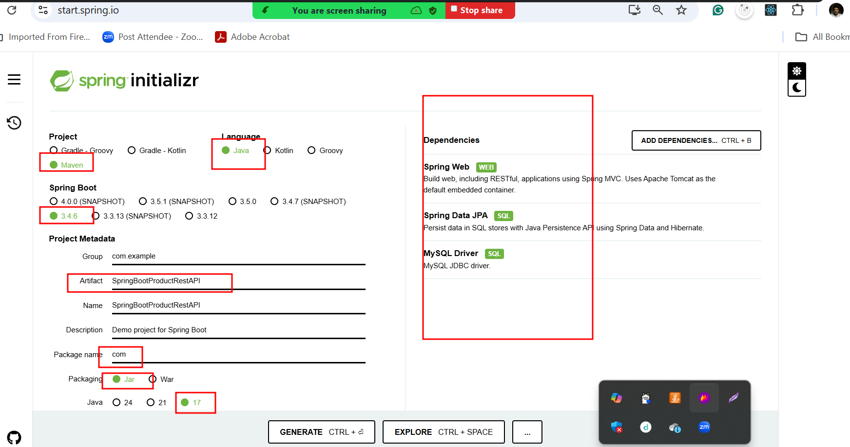

Post man client plugin

If we want to find data using any other key but not primary key. Then we need to write custom method with Query annotation using JPQL

